Nancy’s Knit Knacks LLC
_______________________________________________________

Anything but Lazy Kate™
Cone Accessory Kit

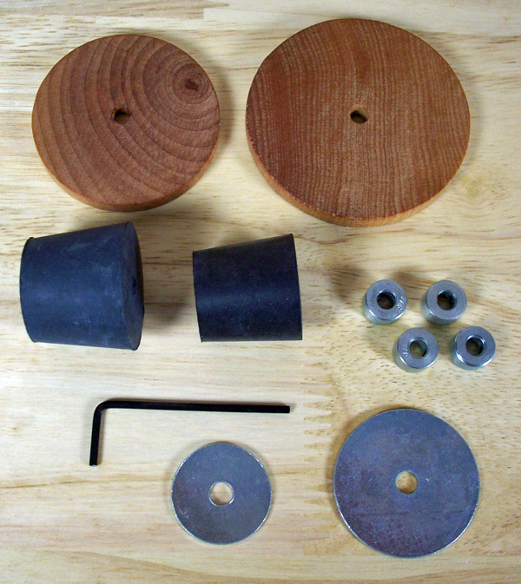
Thank you for purchasing our Cone Accessory Kit. This kit will enable you to use a 7” tall cone on your ABLK Lazy Kate. This kit can also be used with our other Yarn/Cone Stand products.
Tools needed: an Allen Wrench, which is included

Kit contents:
The kit contains 2 wooden discs (2” and 2-7/16” diameters), 3 rubber stoppers (#5, #6, & #4 size (not shown)), 4 3/16” steel collars, and 2 steel washers. Depending on the size cone that you are using, you will install one of the wooden discs (one from this kit or from the Yarn Pet) on the end of the rod - select the disc that fits inside the cone easily but does not have to go up inside the cone too far. Note: the rod came with the Yarn Pet and is not included in this kit.

Basically, you push the disc up inside the cone and when the disc touches the sides of the cone’s interior, pull it out and attach a collar underneath the disc. Recheck fit by sliding inside the cone again. Make sure you have enough rod protruding from both the bottom and the top of the cone. If that location gives you the proper position of the cone on the rod, then remove the cone and tighten collars on both sides of the disc to trap the disc between the 2 collars. Then re-insert the cone on the rod and place the rod into the Yarn Pet.

Note: be sure not to make the collars too tight when sandwiching the wood disc between them. The disc must rotate freely but not wobble. Also, don’t over-tighten the collars or you may mar the rod and make it difficult to slide the collars up and down.

Mount the rod into the base of the ABLK. Then slide your cone onto the rod and it should go down and over the wood disc. You may have to adjust the height of the collars and disc to best fit the cone so adjust it as necessary. You want space underneath the cone so it does not touch the wood base and you want some portion of the rod extending above the cone so you can mount either a metal washer or a rubber stopper.

The rubber stoppers are the preferred way to center the top of the cone on the rod so insert the one that best fits into the cone that you are mounting. If you have an unusually sized cone and the stopper does not fit then use the washer and one collar to lightly press the top of the cone and center it that way. Two different size washers are provided. We have other size rubber stoppers available as well.

11” rods are available which can hold 10” (taller) cones. A table clamp assembly is also available to secure the Pet.

The cone should not rest on the top of the wood base, it should turn freely.
If using this kit with the ABLK, place this assembly in the middle position on the lid of the ABLK.

Tensioning System for the cone:
Use the tensioning post to apply tension to the yarn coming off of the cone. You do this by turning the wireform after loosening the knob. You can make the tension as severe as you like.

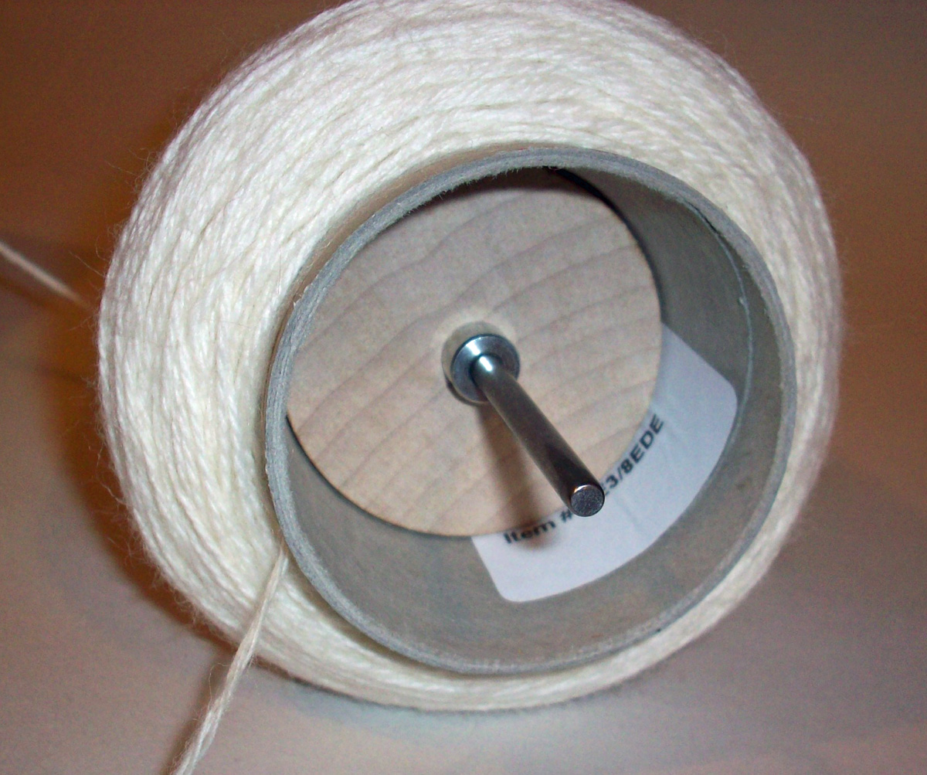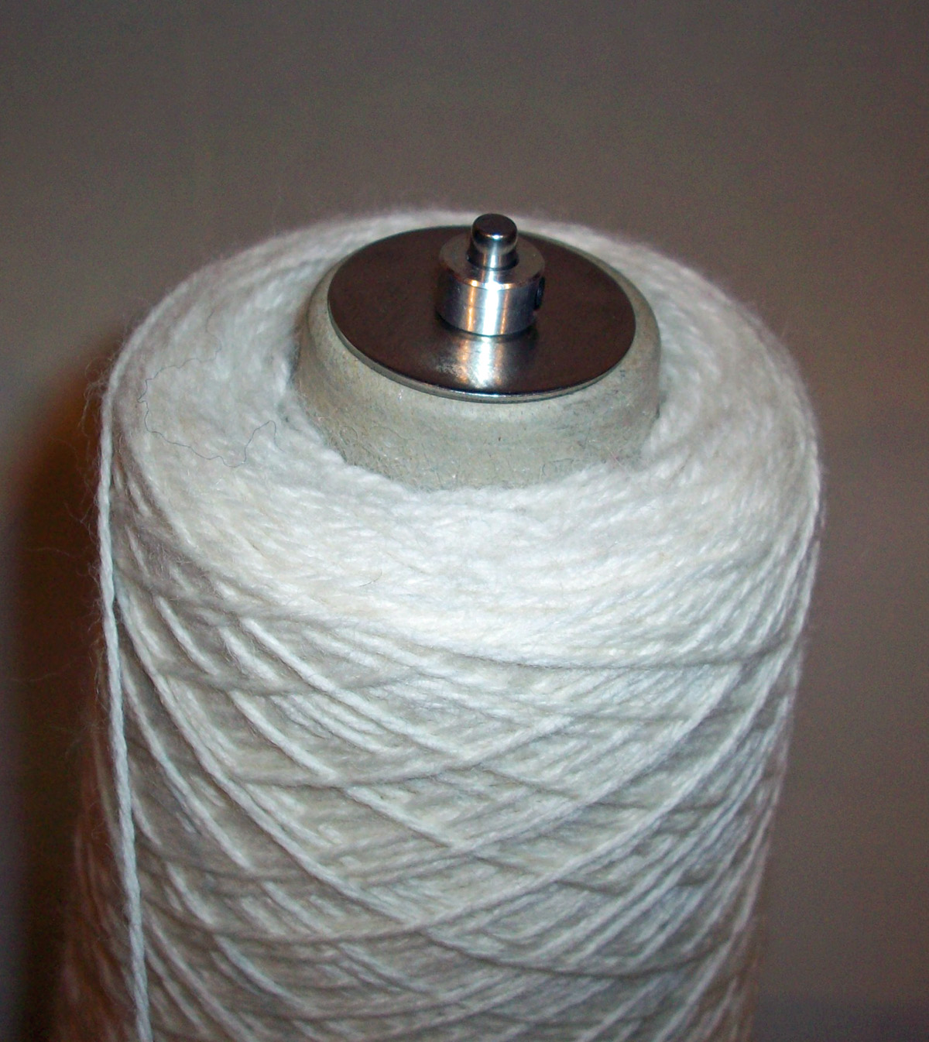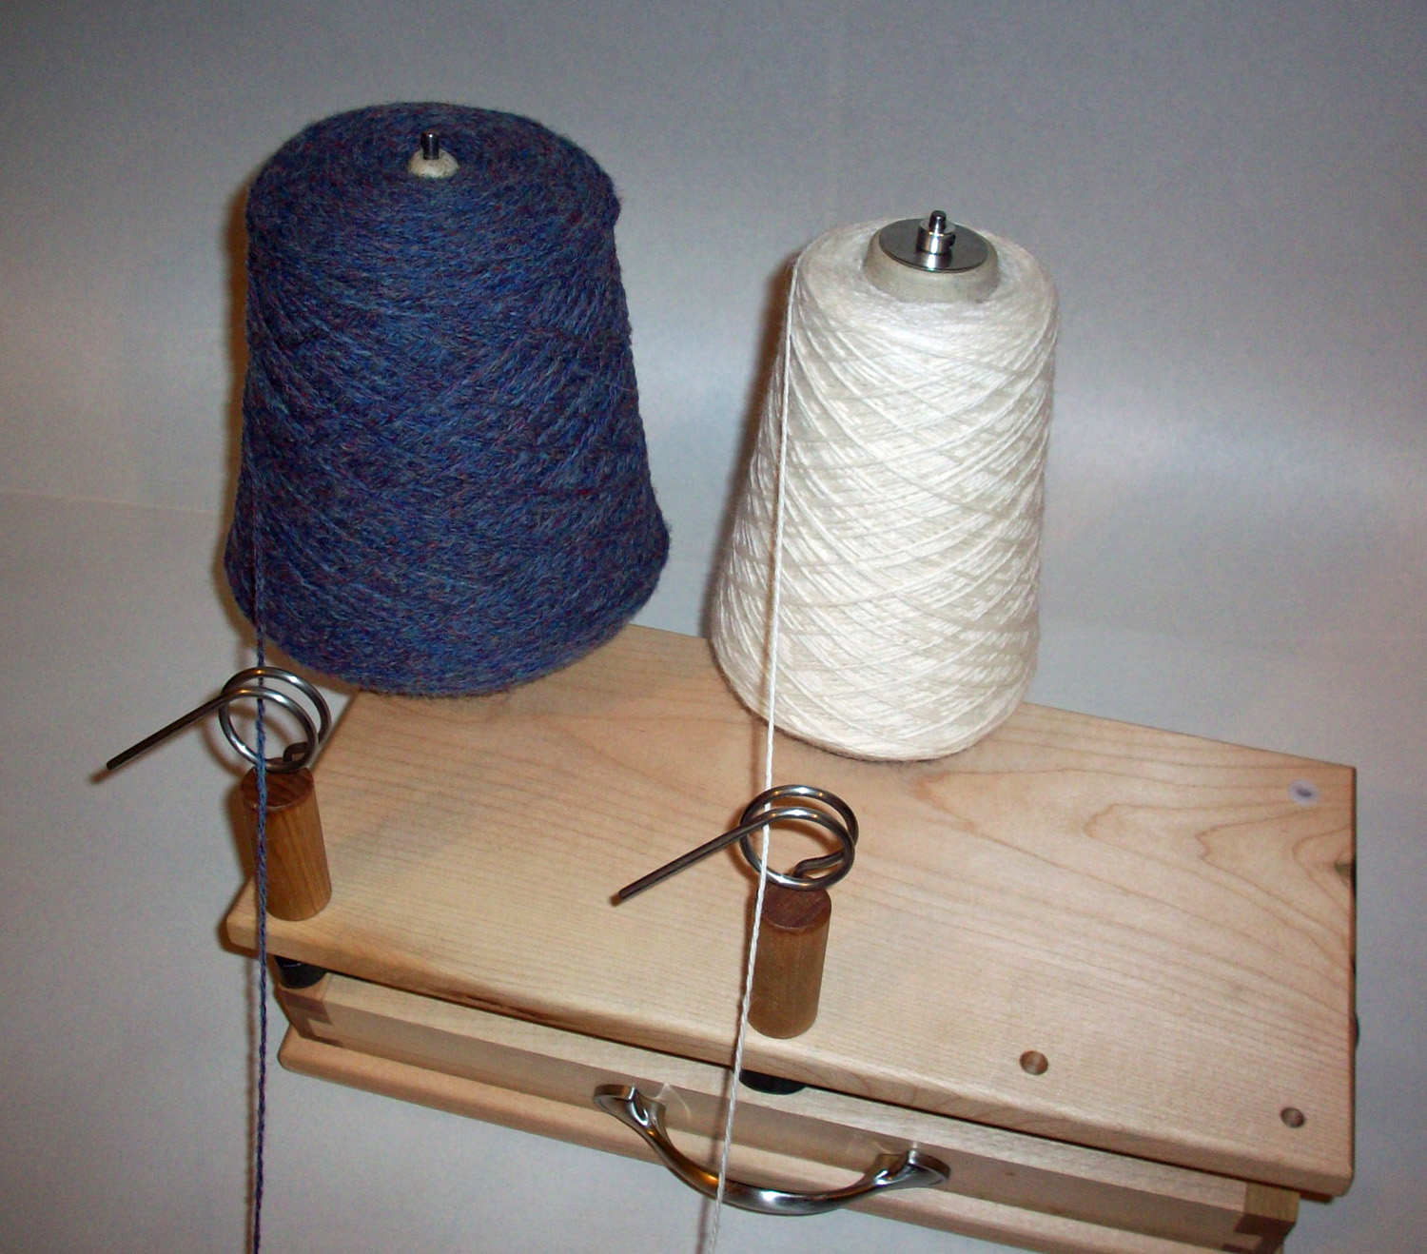

We hope that you enjoy using the Cone Accessory Kit with your ABLK or other NKK yarn stand products.

